How to compile QT projects for MS Visual Studio (2013)

First install Qt 5.5 and then install Visual Studio Add-in 1.2.4 for Qt5 (156 MB). After successful installation run MS VS. There is a new entry in the MS VS top menu bar named "QT5".
Visual Studio 2012:
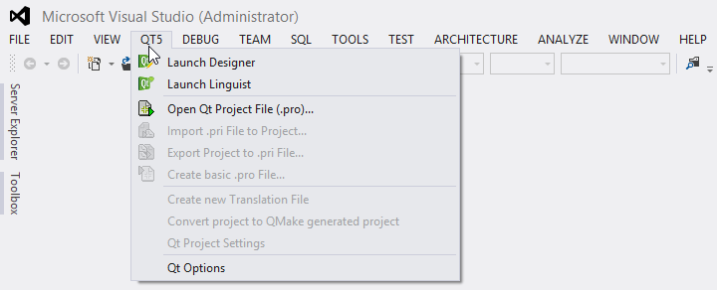
Visual Studio 2010:

Check if the Qt5 add-in is looking to right Qt version by going to top menu, Qt5->Qt Options.
The following example shows the correct path to Qt5.4 for MSVS2013 with opengl:
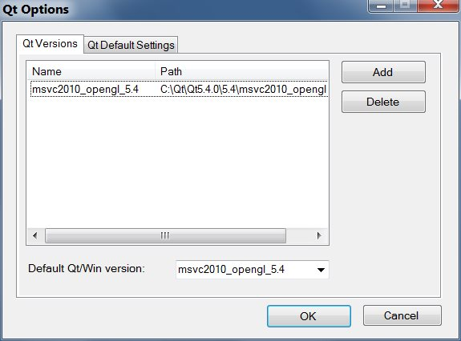

Every Qt project has a .pro file. This file contains the list of headers, sources and compiler flags, modules, and third party libraries. It is recommended for Qt developer to maintain this file. The advantage is that you can easily compile your Qt project under Mac or Linux. You can use a text editor to create or edit it.
To load your Qt project into MS VS, you need to go to top menu, Qt5->open Qt project (.pro) and navigate to the folder that contains all source codes and project (.pro) file. The add-in will create a .vcproj and .sln for your MS VS. After its loaded you can edit, compile, and debug your code within MS VS environment. It is important to remember whenever you add a new .cpp and/or .h to your project,
you need to add it (.pro) file and then reload your project to MS VS by going to Qt5-> open Qt project (.pro).

The following screen shots depicts the steps for loading a Qt project from example folder:
